

Lab Journal: 02
Date: 02/03/2026

Student : Lotfullah Muslimwal
Enrollment : 01-131232-039

Department of Software Engineering

Bahria University, Islamabad

Web – Engineering - Lab (Spring-2026)
Teacher: Engr. SUBAS BILAL

Task No: | Task Wise Marks |  | Documentation Marks |  | Total Marks  (20)
Task No: | Assigned | Obtained | Assigned | Obtained | Total Marks  (20)
1 | 3 |  | 5
2 | 3 |  | 5
3 | 3 |  | 5
4 | 3 |  | 5
5 | 3 |  | 5

Comments:

Signature

Lab No: 02 - Lab Title: Working with HTML 5

Introduction
Implemented the basic tags in the HTML5 inside the VS Code

Tools Used
VS Code

Task 1:
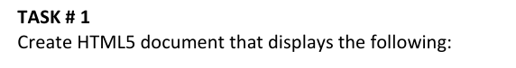
Code
<!DOCTYPE html>
<html lang="en">
<head>
<meta charset="UTF-8" />
<meta name="viewport" content="width=device-width, initial-scale=1.0" />
<title>Task 1</title>
</head>
<body>
<h1>Famous Cities</h1>

<section>
<h2>London</h2>
<p>
London is the capital city of England. It is the most populous city in
the United Kingdom, with a metropolitan area of over 13 million
inhabitants.
</p>

<h2>Paris</h2>
<p>Paris is the capital and most populous city of France.</p>

<h2>Tokyo</h2>
<p>
Tokyo is the capital of Japan, the center of the Greater Tokyo Area, and
the most populous metropolitan area in the world.
</p>
</section>
</body>
</html>

Screenshot
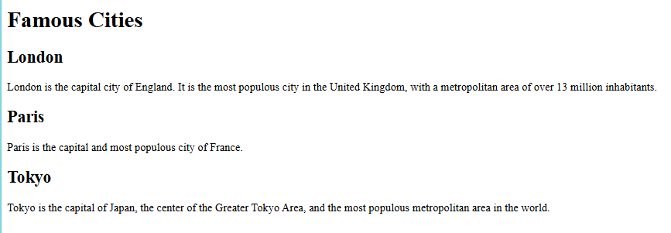
Task 2:
Code
<!DOCTYPE html>
<html lang="en">
<head>
<meta charset="UTF-8" />
<meta name="viewport" content="width=device-width, initial-scale=1.0" />
<title>Feedback Form</title>
</head>

<body>
<div>
<h1>Feedback Form</h1>
</div>

<form method="POST" action="http://www.bahria.com">
<div>
<fieldset>
<legend>Personal Information</legend>
<div>
<label for="name">Name:</label>
<input type="text" id="name" name="name" required />
</div>
<br />
<div>
<label for="email">E-mail:</label>
<input type="email" id="email" name="email" required />
</div>
</fieldset>
</div>
<br />

<div>
<fieldset>
<legend>What did you like most about the campus?</legend>
<div>
<input type="checkbox" id="campus" name="likes" value="campus" />
<label for="campus">Campus</label>
</div>

<div>
<input
type="checkbox"
id="students"
name="likes"
value="students"
/>
<label for="students">Students</label>
</div>

<div>
<input
type="checkbox"
id="location"
name="likes"
value="location"
/>
<label for="location">Location</label>
</div>

<div>
<input
type="checkbox"
id="atmosphere"
name="likes"
value="atmosphere"
/>
<label for="atmosphere">Atmosphere</label>
</div>

<div>
<input type="checkbox" id="dorm" name="likes" value="dorm_rooms" />
<label for="dorm">Dorm Rooms</label>
</div>

<div>
<input type="checkbox" id="sports" name="likes" value="sports" />
<label for="sports">Sports</label>
</div>
</fieldset>
</div>
<br />

<div>
<fieldset>
<legend>How did you become interested in the college?</legend>
<div>
<input type="radio" id="friends" name="interest" value="friends" />
<label for="friends">Friends</label>
</div>

<div>
<input
type="radio"
id="television"
name="interest"
value="television"
/>
<label for="television">Television</label>
</div>

<div>
<input
type="radio"
id="internet"
name="interest"
value="internet"
/>
<label for="internet">Internet</label>
</div>

<div>
<input type="radio" id="other" name="interest" value="other" />
<label for="other">Other</label>
</div>
</fieldset>
</div>
<br />

<div>
<fieldset>
<legend>Additional Comments</legend>
<textarea name="comments" rows="5" cols="40"></textarea>
</fieldset>
</div>
<br />

<div>
<button type="submit">Submit</button>
<button type="reset">Reset</button>
</div>
</form>
</body>
</html>

Screenshot
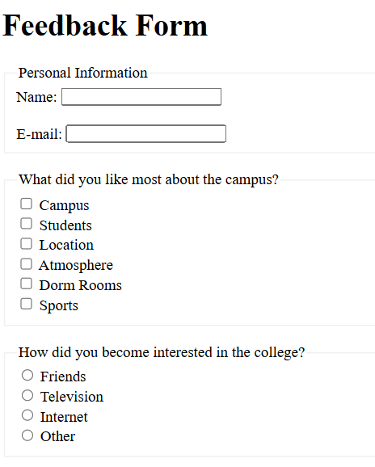
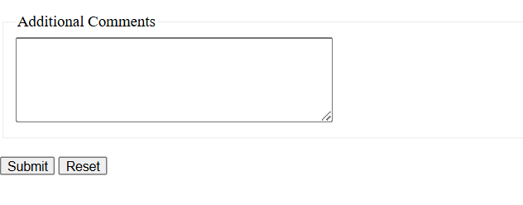

Task 3:

Code
<!DOCTYPE html>
<html lang="en">
<head>
<meta charset="UTF-8" />
<meta name="viewport" content="width=device-width, initial-scale=1.0" />
<title>Kindergarten Fun Page</title>
</head>
<body>
<header>
<h1>Welcome to Kindergarten Fun Page</h1>
<p>Learn and have fun with songs and rhymes!</p>
</header>

<section>
<h2>National Anthem</h2>
<audio controls>
<source src="anthem.mp3" type="audio/mpeg" />
Your browser does not support the audio element.
</audio>
</section>

<section>
<h2>Famous Rhymes Videos</h2>

<figure>
<iframe
width="320"
height="240"
src="https://www.youtube.com/embed/yCjJyiqpAuU"
title="Twinkle Twinkle Little Star"
frameborder="0"
allowfullscreen
></iframe>
<figcaption>Twinkle Twinkle Little Star</figcaption>
</figure>

<figure>
<iframe
width="320"
height="240"
src="https://www.youtube.com/embed/nrv495corBc"
title="Humpty Dumpty"
frameborder="0"
allowfullscreen
></iframe>
<figcaption>Humpty Dumpty</figcaption>
</figure>

<figure>
<iframe
width="320"
height="240"
src="https://www.youtube.com/embed/CRHvTTOR8Ns"
title="Baa Baa Black Sheep"
frameborder="0"
allowfullscreen
></iframe>
<figcaption>Baa Baa Black Sheep</figcaption>
</figure>

<figure>
<iframe
width="320"
height="240"
src="https://www.youtube.com/embed/FYojUSFfuMg"
title="Jack and Jill"
frameborder="0"
allowfullscreen
></iframe>
<figcaption>Jack and Jill</figcaption>
</figure>

<figure>
<iframe
width="320"
height="240"
src="https://www.youtube.com/embed/CkRdvGmcCBE"
title="Mary Had a Little Lamb"
frameborder="0"
allowfullscreen
></iframe>
<figcaption>Mary Had a Little Lamb</figcaption>
</figure>
</section>

<section>
<h2>Contact Us</h2>
<p>Send us an email by clicking the image below:</p>
<a href="mailto:lotfullahmsl@gmail.com">
<img
src="foremail.jpg"
alt="Click here to send us an email"
width="100"
height="100"
/>
</a>
</section>

<footer>
<p>Kindergarten Fun Page &copy; 2026</p>
<p>Learning made fun for kids!</p>
</footer>
</body>
</html>

Screenshot

